**DAILY ONLINE ACTIVITIES SUMMARY**

|  |  |  |  |  |  |  |  |
| --- | --- | --- | --- | --- | --- | --- | --- |
| **Date:** | **26-05-2020** | | | | **Name:** | **PUNITH S** | |
| **Sem & Sec** | **4th Sem B sec** | | | | **USN:** | **4AL18CS064** | |
| **Online Test Summary** | | | | | | | |
| **Subject** | | **Design and Analysis of Algorithm** | | | | | |
| **Max. Marks** | | **30** | | **Score** | | **21** | |
| **Certification Course Summary** | | | | | | | |
| **Course** | **Machine Learning with Python.** | | | | | | |
| **Certificate Provider** | | | **[Cognitiveclass.ai](http://Cognitiveclass.ai" \o "http://Cognitiveclass.ai)** | **Duration** | | | **12 hours** |
| **Coding Challenges** | | | | | | | |
| **Problem Statement: 1.permutation 2.Subarray that starts and ends with same elements 3.count digits 4.not divisible by 2 and 3 5.palindrome 6.series.**  **triplets such that sum of two elements equals the third element.**  **Problem Statement 2: Write a C program to check whether the two strings are Anagram**  **or not.** | | | | | | | |
| **Status: C**ompleted | | | | | | | |
| **Uploaded the report in Github** | | | | **Yes** | | | |
| **If yes Repository name** | | | | **[https://github.com/puni2426/lockdown-coding](https://github.com/puni2426/lockdown-coding" \o "https://github.com/puni2426/lockdown-coding)** | | | |
| **Uploaded the report in slack** | | | | **Yes** | | | |

Online Test Details: (Attach the snapshot and briefly write the report for the same)

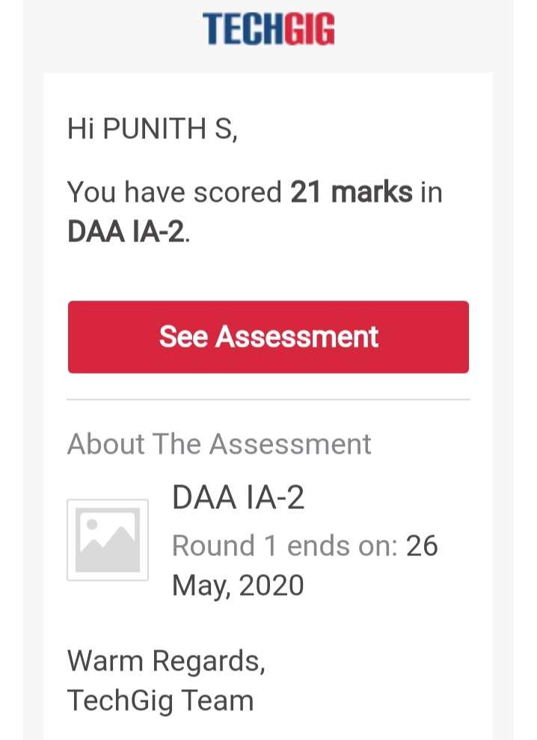

Design and Analysis of Algorithm Internals was conducted. A total of 30 questions each carries 1 marks and time is between 09:15 am to 10:00 am.The above snapshot is the result sheet which was mailed to us by the Techgig team.

Certification Course Details: (Attach the snapshot and briefly write the report for the same)

**NAME :PUNITH S**

**USN : 4AL18CS064**

**COURSE NAME : Python with Machine Learning**

**LINK : <https://cognitiveclass.ai/courses>**

**Cognitive Class: ML0101ENv3**

**Org By : IBM**

**Start date : 20-05-2020**

**Duration : 12 hr**

**Progress on :26-05-2020**

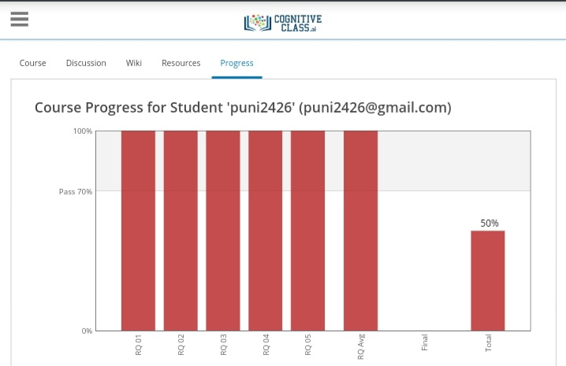

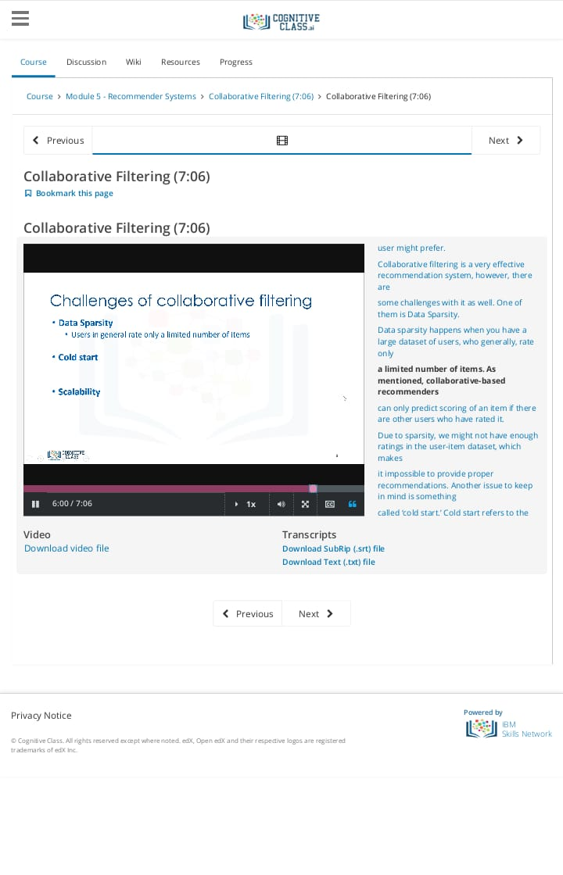

Coding Challenges Details: (Attach the snapshot and briefly write the report for the same)

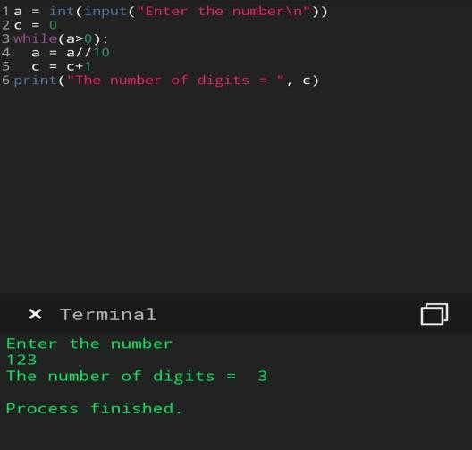

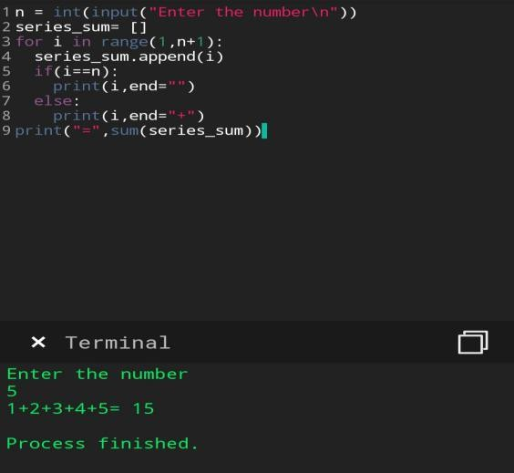

**1.permutation**

**2.Subarray that starts and ends with same elements**

**3.count digits**

**4.not divisible by 2 and 3**

**5.palindrome**

**6.series.**

[https://github.com/puni2426/lockdown-coding](https://github.com/puni2426/lockdown-coding" \o "https://github.com/puni2426/lockdown-coding)

[https://github.com/puni2426/lockdown-certificate-course](https://github.com/puni2426/lockdown-certificate-course" \o "https://github.com/puni2426/lockdown-certificate-course)